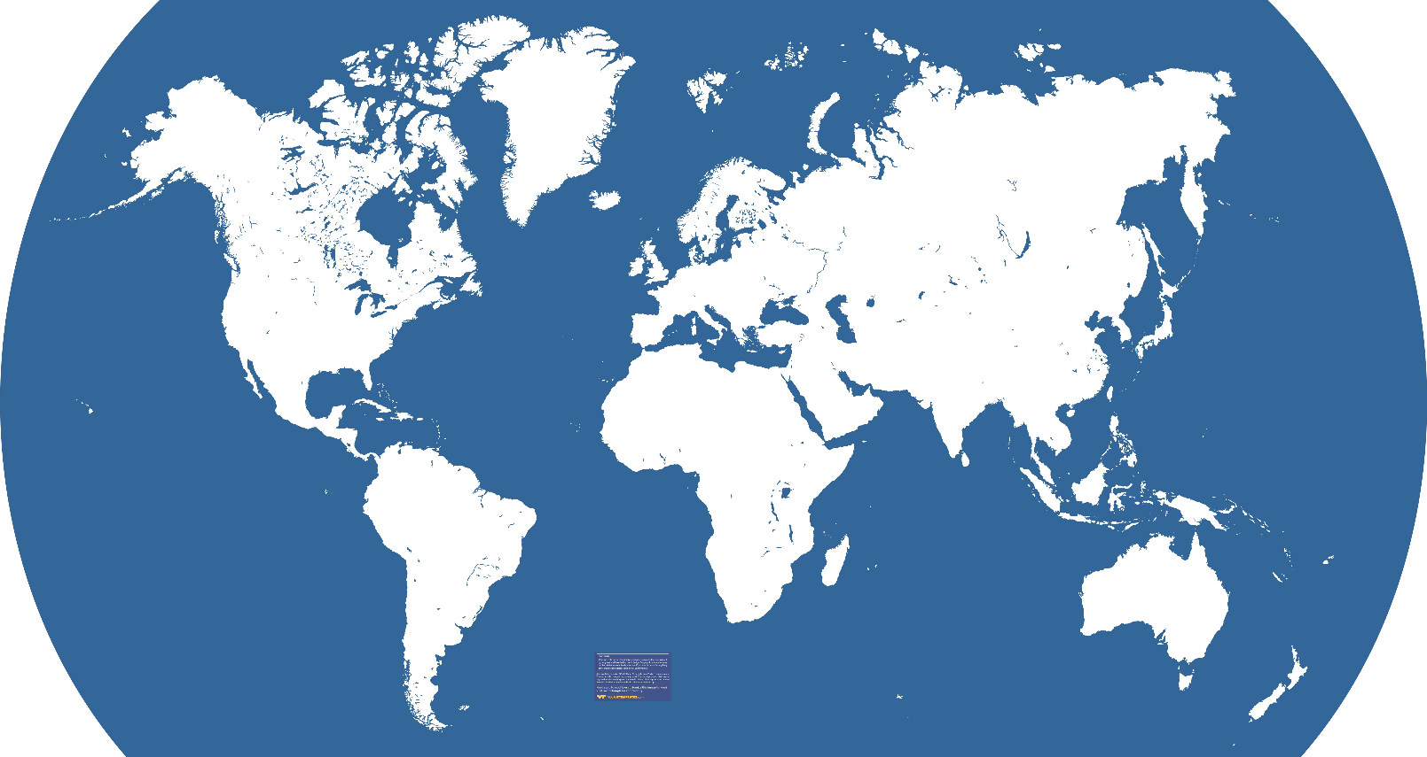
Label the following (put the correct letter by each number):
- USA 5.) Nile River Valley
- Mesopotamia 6.) Ancient China
- Atlantic Ocean 7.) South America
- Indus River Valley 8.) Australia

Fill in the chart below:
Mesopotamia Nile River Indus River China
River(s)

Writing

Innovations

Geography

Climate

Look at page 381 – Answer questions 1-4
Look on page 394 – Create a bar graph using the information at the top of the page.
Look on page 399 – Answer questions 1-4
Look at page 436. Respond to the Journal Entry at the bottom of the page.

